2.Create a **“.log”** file and a **log folder** in the working directory of Git. Update the **.gitignore** file in such a way that on committing, these files (.log extensions and log folders) are ignored.

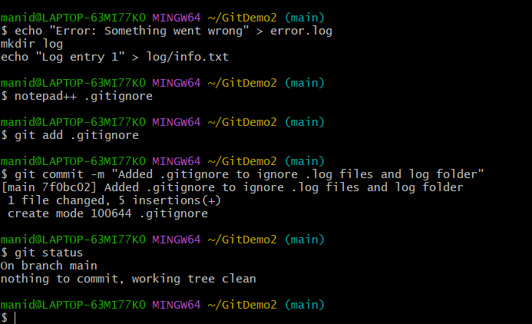

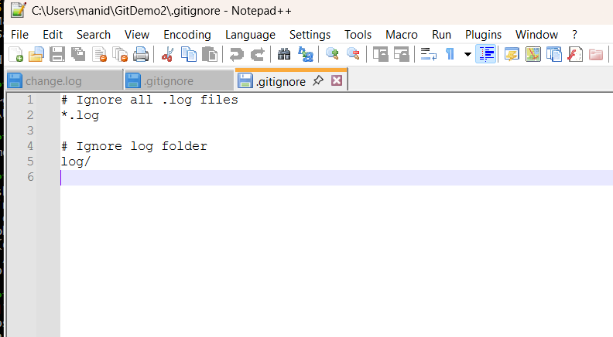d log folders) are ignored